9.57:
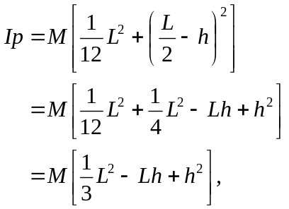
which is the same as found in Example 9.12.

